Week 2 Activity 2 of Bionexam Summer Internship
Submitted By: Hadia
MODULE 1: NUCLEOTIDE RETRIEVAL & SEQUENCE TRANSLATION
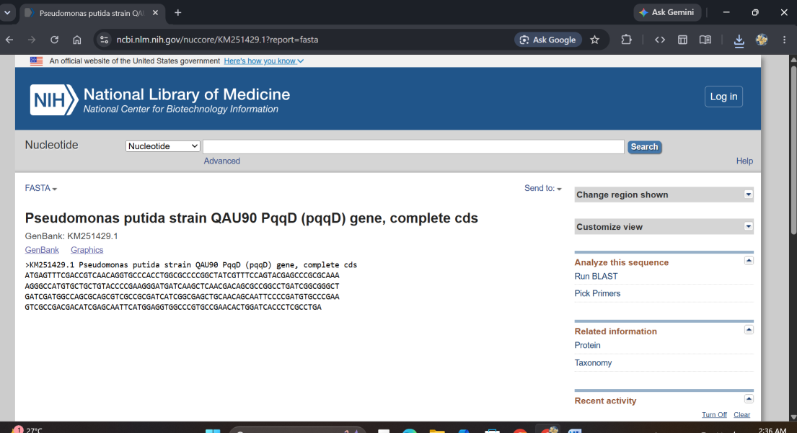

Step 1.2: Protein Sequence Translation
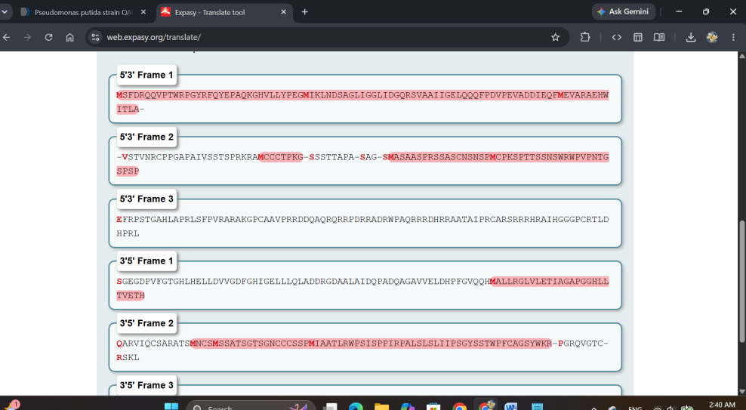
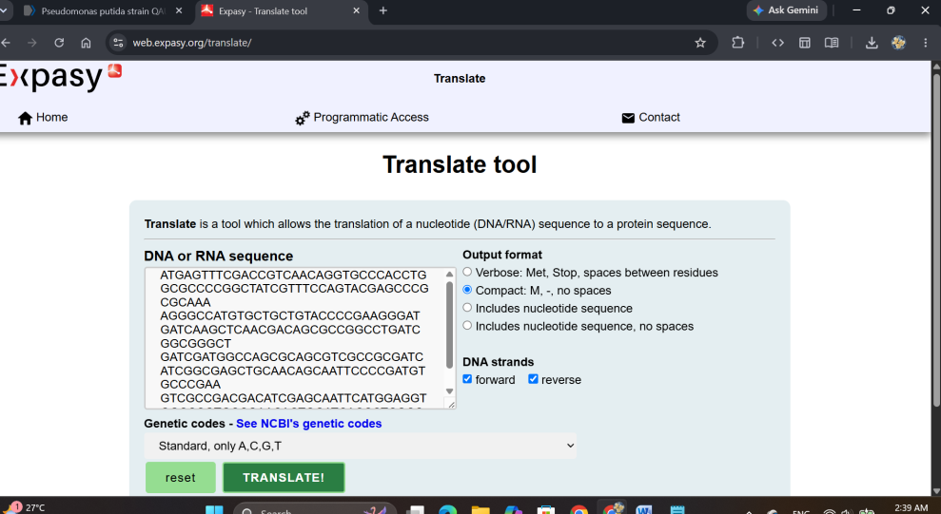

MODULE 2: STRICT MANUAL PRIMER DESIGN
Step 2.1: Manual Oligonucleotide Selection
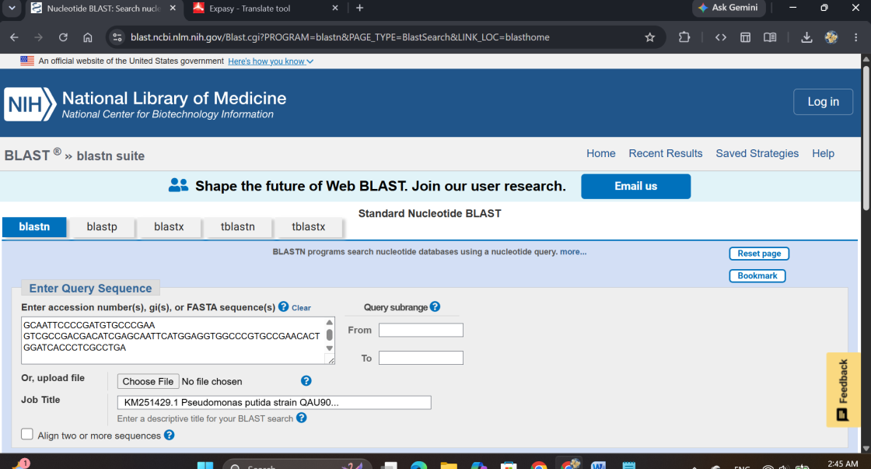

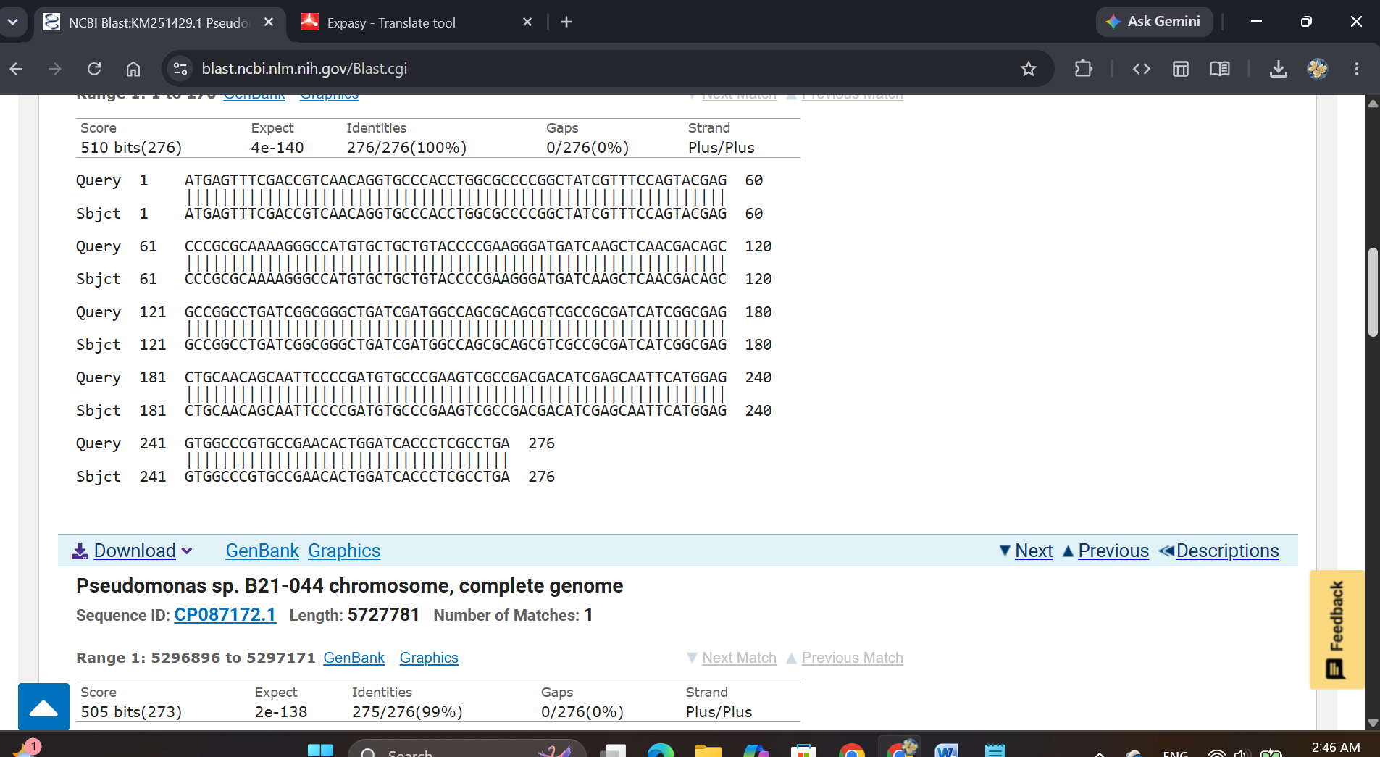

CCAGTACGAGCCCGCGCAAAAG ----------- Forward primer candidate
Len=22, Tm= 60 degree Celsius, GC content= 64%

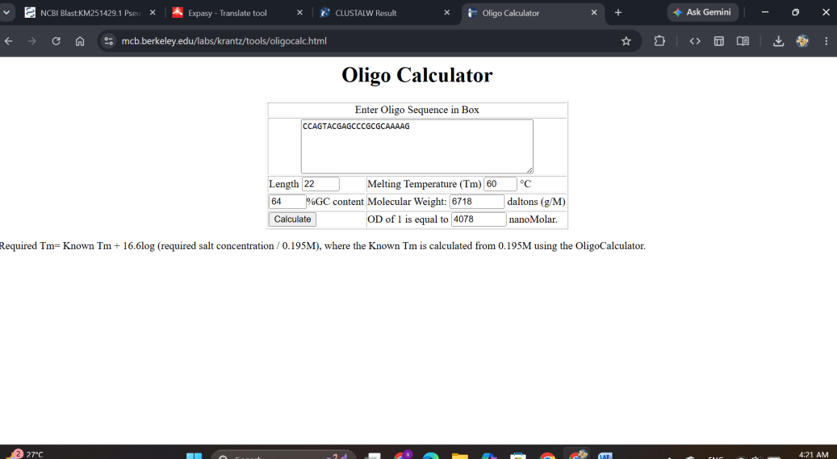

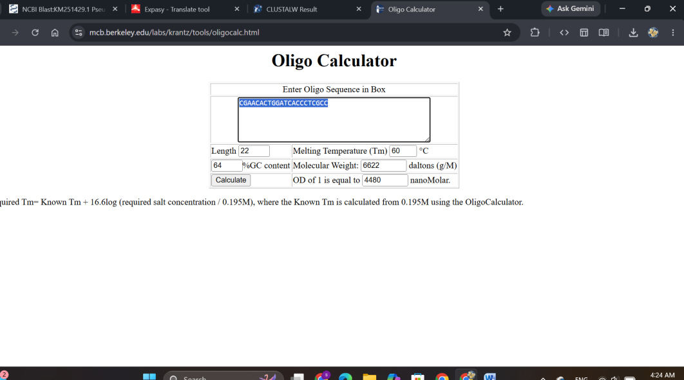
CGAACACTGGATCACCCTCGCC------ Reverse primer candidate
Length=22, Tm=60 degree Celsius, GC content=64%

Reverse complement:
GGCGAGGGTGATCCAGTGTTCG

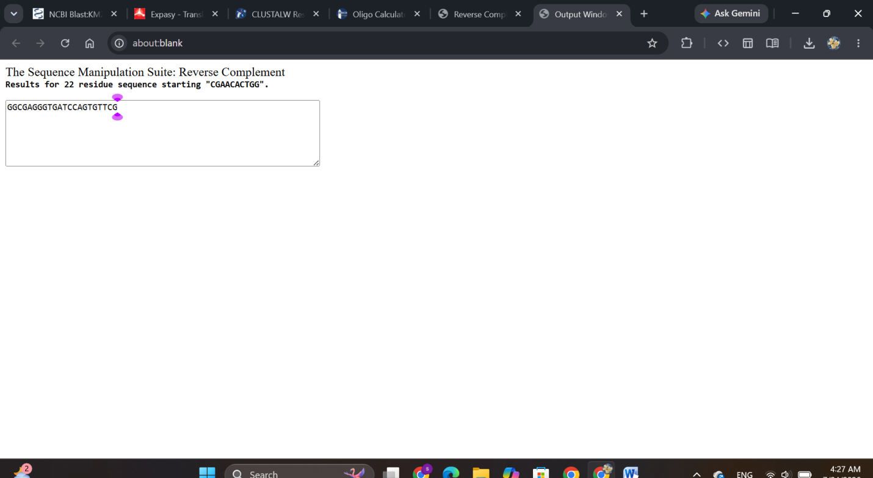
MODULE 3: ALIGNMENT & PHYLOGENY WITH MEGA 12
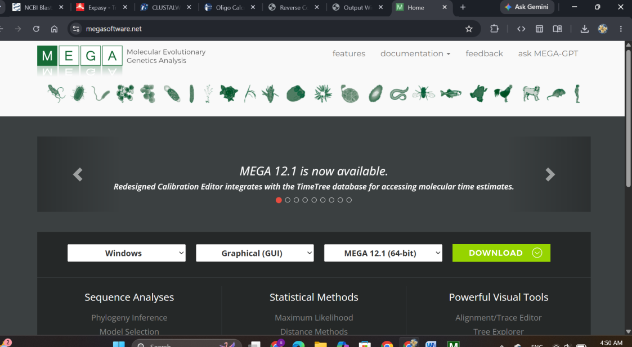

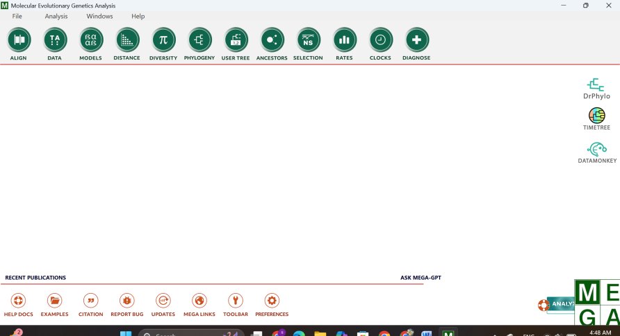

Aligned Sequence:
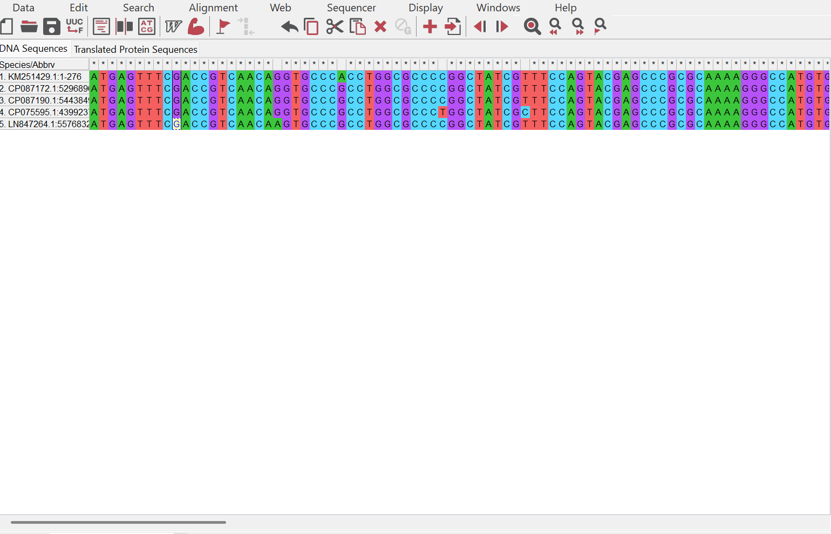

Phylogeny:
